

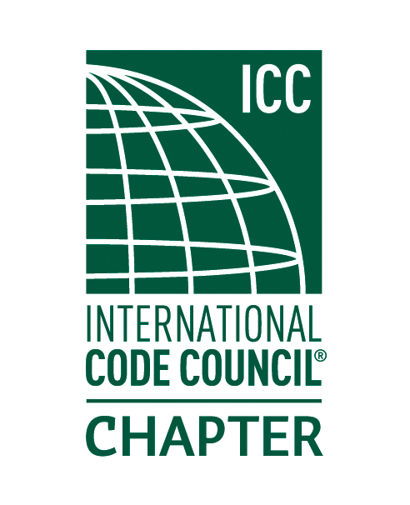

2017

BOARD OF DIRECTORS:

PRESIDENT

LOWELL BROWN

Insp. Services Mgr.

TRB + Associates

VICE-PRESIDENT

RON BEEHLER

Director

Interwest Consulting Group

SECRETARY

Tim Scott

Assistant Building Official

City of Davis

TREASURER

GENE ASHDOWN

Building Official

City of Winters

PAST-PRESIDENT

VIRGINIA BUGBEE

Permit Technician

Solano County

.

***October 4th, 2017 AGENDA***

**CALL TO ORDER:** the meeting starts around 5:30 at The Clubhouse at Paradise Valley 3990 Paradise Valley Rd, Fairfield, CA 94533

**ROLL CALL OF OFFICERS:**

**INTRODUCTIONS:**

**DINNER MENU:**

Entrée: Baked Center-Cut Pork Loin,

Salad: Mediterranean Salad,

Sides: Herb Roasted New Potatoes and Fettuccine Alfredo,

**GUEST SPEAKER:**

● Our guest speaker this month will be Greg Mahoney, Greg will be speaking about “tiny Houses”

**CORRESPONDENCE:**

**CODE QUIZ:**

**COMMITTEE REPORTS**

• Education

• Treasurer

• CALBO

• CSLB

• Building Standards

• Region One

**UNFINISHED BUSINESS:**

● Discussion of amendment to bylaws presented by Harvey Higgs at last meeting.

● CBOAC Donation for October Annual Business Meeting

**NEW BUSINESS:**

**●** Nominations for new Secretary

**INDUSTRY REPRESENTATIVE ANNOUNCEMENTS:**

**ADJOURNMENT:**